Software Design Document

Fall CSCI 325
October 26, 2015

Connect Four Game

Susan Phillips
Patrick Pullum
Alex Waters
Shawn Singleton
Curtis Oliver

Table of Contents

1.0 Introduction

1.1 Purpose
1.2 Scope
1.3 Glossary
1.4 Overview of the game
1.5 Overview of the project

2.0 Team Assignments

3.0 UML Class Diagram

4.0 UML Class Diagram

1.0. Introduction

1.1. Purpose
A description of a basic computer Connect Four Game designed for two players.

1.2. Scope
It is an object oriented program with the primary component of a super button class. Super buttons are used inside a JFrame playing field. Super buttons rely on the action listener interface and the entire project is heavily dependent on the Java.awt. There are six arrays of seven JButtons each which will represent the grid of places to be clicked on.

1.3. Glossary
Super button = A button that has advanced capabilities, mostly keeping track of if anyone has clicked on it.

JFrame and JButton = Components of Graphic User Interface application
Array = A programming language construct used to group and organize data.
Java.awt = Toolkit in Java used for the purpose of windowing applications.

1.4. Overview of the Game

Two players take turns placing colored disc into the top of a seven-column, six-row vertical grid. The object of the game is to connect four of your colored disc either vertically, horizontally or diagonally. Each player continues to strategically place disc in the columns until a player is able to connect all four and is declared the winner.

1.5. Overview of Project

- The game board is a design grid that consists of six arrays of seven JButtons inside a JFrame.
- Once a player clicks on a button the program checks to see if the button below it has changed color.
- Based on whether it has or not it will either change color or check the one below it to see if it changed color and it continues all the way to the last uncolored button.
- A switch (Boolean) allows you to choose whether the disc is going to be red or yellow.
- A check the winner checks for four in a row in four different ways:
- Checks within each array (counter)
- Checks across arrays horizontally at each index
- Checks diagonally – going up
- Checks diagonally – going down

2.0. Team Assignments:

Susan Phillips: Design Grid inside JFrame
Create 6X7 Array of JButtons inside Grid
Alex Waters: Check back-n-forth algorithm
Shawn Singleton: Create a switch that allows you to choose whether it will be red or yellow (Boolean)
Patrick Pullum: Check for 4 in a row:
(Check within each array – counter)
(Check across arrays horizontally at each index)
Curtis Oliver: Check for 4 in a row:
(Diagonally – going up)
(Diagonally – going down)

3.0. UML Class Diagram

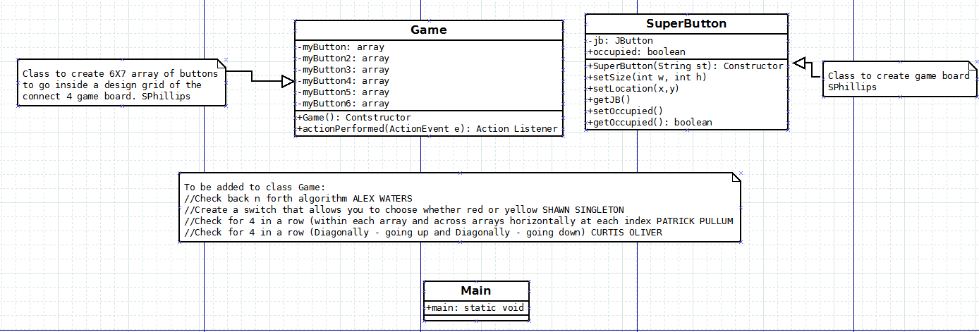

4.0. UML Class Diagram

